Given Data:

R=10Ω，

L=30mH= 30 x 10-3H

C=1uF= 1x 10-6 F

U=1.414V

f1& f2 are frequencies of half-power points

f1=? f0=? f2=?

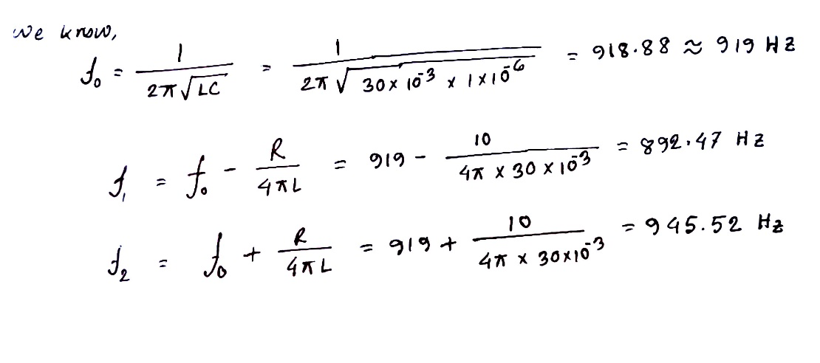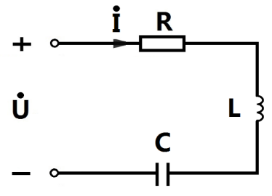

|  |  |  |  |
| --- | --- | --- | --- |
|  |  |  |  |
|  | 892.47Hz | 919Hz | 945.52Hz |